(College logo)



**Project synopsis on**

**DIGITAL BUS WITH AUTOMATIC TICKETING SYSTEM**

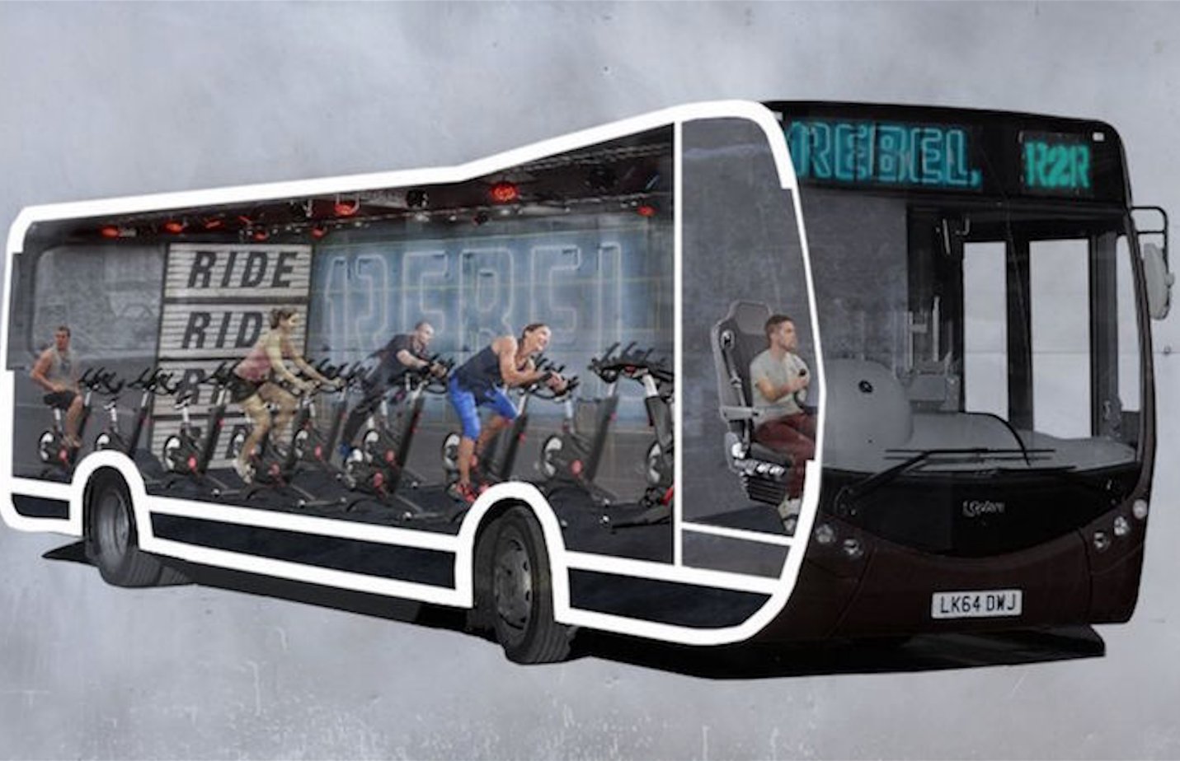

Under taken by:

Name 1 Roll no. 1 Name 2 Roll no. 2

Name 3 Roll no. 3 Name 4 Roll no. 4

**CATEGORY OF PROJECT:**

1. Microcontroller Project
2. Communication Project

**EASY HIGHLIGHTS:**

1. Easy ticketing system in bus
2. No use of Paper ticket
3. Easy to maintain records
4. Single smart card for bus and metro
5. Self-Explanatory Kit Available
6. Synopsis Available
7. Project file available

**ABSTRACT:**

In this project there is a control panel where a user will give the input in the system or to the microcontroller and microcontroller will save the input and according to input it gives command to the motor which shows a dummy bus.

LCDis used for the indication purpose for the user as well as for the driver**.**

Amplification circuit is used to run the motor properly.

IR sensor is used to count the person or user at the time of going out from the bus so that microcontroller will calculate the counter.

For running this project we require +5 volt,+9 volt and for this we used a battery and a voltage regulator 7805.

**WORKING PRINCIPLE:**

Power supply is provided by 9 volt battery .but the microcontroller needs 5 volt battery for its operation so a voltage regulator is used (LM7805) which can operate in the range of 7V -32V .It regulates the DC voltage to 5V.The bigger condenser or capacitor (electrolytic capacitor) is used to remove repulse. Smaller capacitor and adaptor may also be used for power supply. LED at power supply is used to show that the circuit is ON. This LED requires 3 volts power supply to glow, so a resistor is put in between voltage regulator and LED to draw the 5-3 volts.

To reset the whole circuit a switch is used along with a capacitor to remove noise while resetting.

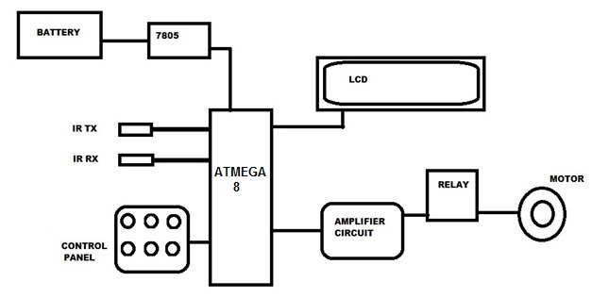**BLOCK DIAGRAM:**

**COMPONENTS REQUIRED**

**Input section-**

1. control panel (Tact switch)
2. IR sensor

**Controlling section-**

Microcontroller Atmega 8 (with 8MHz crystal)

**Output section-**

1. LCD
2. Motor
3. Motor driving IC (L293d)

**Other components-**

1. Power supply- battery (9V)
2. voltage regulator IC (LM7805)

**APPLICATIONS:**

**1. ECO FRIENDLY:** No need of paper in this ticketing system so as a result of it prevents cutting of extra trees for its purpose.

2. **RECORD MAINTENANCE**: Maintaining record of every route and revenue collected from sale of tickets during that would become easy as everything will be stored digitally.

**3.** As everyone has to enter his or her boarding station and departure location so there won’t be any issue of like those people who averts to buy ticket which would add to the revenue eventually.

**REFERENCES:**

* engineersgarage.com
* 2.electronicsforu.com
* 3Book:.AVR Programming by Elliot Williams